3rd Annual Summer SFO Seminar

Endorsed by the National Executive Council of the SFO

“Peace and Justice
for Secular Franciscans”

Presenters:

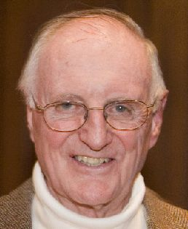
Fr. Joseph Nangle, OFM and

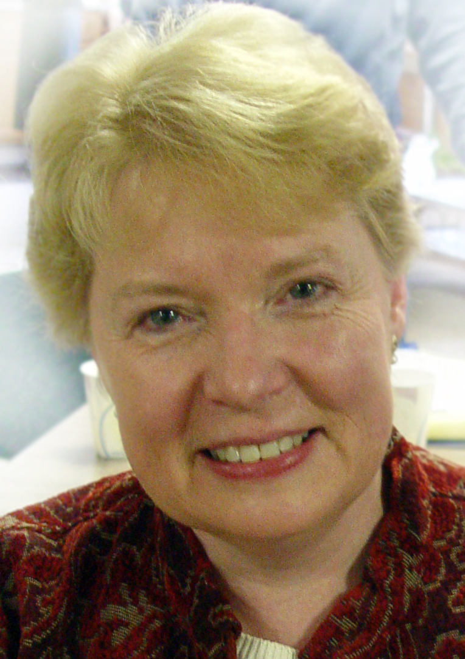
Pat Brandwein-Ball, SFO

Thursday evening, June 24, 2010 - Sunday lunch, June 27, 2010

St. Francis University
Loretto, PA

Fr. Joseph Nangle, OFM

Fr. Joseph presently serves as the treasurer and secretary for the Franciscan Action Network (FAN) Board of Directors. He recently retired from Franciscan Mission Service (FMS) in Washington, DC, of which he was a co-founder. The FMS is an overseas lay mission program of the Franciscan family (brothers, priests, sisters, and lay Franciscans) in North America. It screens, trains, places, and supports lay women and men for work in under-developed areas of the world. A member of the Franciscan Friars of Holy Name Province, he currently ministers to the Hispanic community at Our Lady Queen of Peace Parish, Arlington, VA.
For the past twenty-two years Fr. Joseph has lived at the Assisi Community, an intentional live-in-community in inner city Washington, DC that he helped establish. Consisting of two vowed members and a number of lay women and men, the Assisi Community strives for a simple lifestyle while engaging in a variety of activities and ministries for justice and peace.
Promoting Peace and Justice, Fr. Joseph has served in the Office for International Justice and Peace for the USCCB, as Justice and Peace Director for the Conference of Major Superiors of Men, as an executive committee member of the Pax Christi USA, as a board member of the U.S. Catholic Mission Association (USCMA) and was on the staff of Sojourners Magazine as Outreach Director and editorial writer.
His service as a missionary in Bolivia and Peru for 15 years during the rise of liberation theology is captured in his book “Birth of a Church” that tells how one parish lived the vision of this theology. He also is co-author of "Say to This Mountain": Mark's Story of Discipleship, and “St. Francis and the Foolishness of God,” a book used in the Institute for Contemporary Franciscan Life program at St. Francis University.


Patricia Brandwein-Ball, SFO

Pat is our newly appointed chair of JPIC, (Justice, Peace, and the Integrity of Creation). She was appointed in October 2009, having served as chair of both the ad hoc committee to revise the apostolic commissions and the JPIC transition.
Pat has served the Secular Franciscan Order in elected leadership since 1992. She has served as local minister of the Seven Joys of the Blessed Virgin Mary Mother of God Fraternity, Kennebunkport, ME; St. Casimir Provincial Minister; St Elizabeth of Hungary, Vice-Minister, then Regional Minister; and most recently, National Councilor. Pat is a member of the Spirit and Life Team. She travels extensively throughout New England and the country in service to the SFO.
Pat is a member of Our Lady of the Angels parish in Berwick, ME. She served many years ago as Confirmation CCD teacher and more recently served as a Eucharistic Minister and as part of the church cleaning crew.
Pat is a retreat director and facilitator, Spiritual Director of individuals and groups. She is a member of Spiritual Directors International. She holds a BA in Psychology from the University of New Hampshire. She is an LPN working as a pediatric nurse.
Pat lives in Maine with her husband and 2 adult sons. She is a passionate gardener and collector of amaryllis varieties.

The Topic: Peace and Justice
The seminar will begin on Thursday evening with dinner at 5, followed by Evening Prayer, introductions, and an overview of the seminar’s topic, Peace and Justice.
The sessions on Friday will focus on Catholic Social Teaching – its history and its view of the Human Person and Creation. On Saturday we will explore the Franciscan view of the Human Person along with a further look at Catholic Social Teaching and Spirituality. The last session on Saturday will focus on Justice, Peace and the Integrity of Creation (JPIC) – its mission and vision statements. Our Rule and Constitution will be key elements in the sessions. The Third Annual SFO Summer Seminar in Loretto wraps up on Sunday with a final session and lunch.

SFO LEADERSHIP SEMINAR

Tentative Schedule

THURSDAY, JUNE 24
Afternoon – Registration beginning 1 P.M.
(Eucharist available at Campus Chapel at 12 Noon for early arrivals) (Christian Hall)
5:00 – Dinner (Torvian Dining Hall)
6:15 – Evening Prayer (DiSepioInstitute) Welcome and Introduction to the seminar
7:00 – Session #1 – Overview of Seminar
Theological Reflection: “Presence” –
Pat & Fr. Joseph
8:30 – Social – Christian Hall

FRIDAY, JUNE 25
8:00 AM – Breakfast (Torvian Dining Hall)
9:15 – Prayer (DiSepio Institute)
9:45 – Session #2 – History of Catholic Social Teaching (CST) - Fr. Joseph
12:00 NOON – Lunch
2:00 PM – Session #3 – CST view of the
Human Person and Creation – Pat Conversion/Response
4:00 – Eucharist (Chapel)
5:00 – Dinner
6:30 – Prayer Experience
7:00 – Session #4 – Spirituality and Catholic Social Teaching - Fr. Joseph
8:30 – Social – Christian Hall

SATURDAY, JUNE 26
8:00 AM – Breakfast
9:15 – Prayer
9:45 – Session #5 – Franciscan view of the Human Person - Pat
Gratitude& Joy/conversion
12:00 NOON – Lunch
2:00 PM – Session #6 – Further Considerations on CST and Spirituality - Fr. Joseph
4:00 – Eucharistic Liturgy for Sunday
5:00 – Dinner
6:30 - Prayer Experience
7:00 – Session #7 – JPIC Mission & Vision Statements - Pat
Response/gratitude and joy/conversion
8:30 – Social – Christian Hall

SUNDAY, JUNE 27
8:00 AM – Breakfast
9:30 – Prayer
10:00 – Session #8 – Conclusions
12:00 NOON – Lunch and Departure

Directions to St. Francis University

By Car:
From Northwestern Pennsylvania: Take I-79 to Rt. 422 east to Ebensburg. In town, turn left at the traffic light onto High Street. Continue straight at next light. Turn left on to Manor Road. Saint Francis University is six miles on the right.

From Cleveland (Ohio area): Take Ohio Turnpike east to I-80 east. Take I-680 south to Route 422 east (approximately 120 miles) to Ebensburg. In town, turn left at the traffic light onto High Street. Continue straight at next light. Turn left on to Manor Road. Follow this road for six miles to the Saint Francis University entrance on right.

From southwestern PA and southeast Ohio: Take Route 22 east from Pittsburgh to second Ebensburg exit (Ebensburg/Loretto exit). Bear right at end of exit ramp. Proceed straight (crossing over Route 22). Turn right at the first light on to Manor Road. Follow this road for six miles to the Saint Francis University entrance on right.

From Northeastern PA/Central New Jersey: Take I-80 south to I-80 west to exit 161 (Bellefonte). Take US99/Rt. 220 south approximately 50 miles to Altoona and Rt. 22 west. Take Rt. 22 west to Lilly/Portage exit. Turn right onto Rt. 53 north. Continue on Rt. 53 north approximately two miles to traffic light (Sheetz on left). Turn left at light and continue beneath railroad overpass. 200 yards beyond overpass, bear right at Saint Francis University sign onto St. Joseph Street. Take this road four miles to Loretto. At Village Cross monument on traffic circle, bear left. Saint Francis University entrance is 200 yards on left.

From Southeastern PA and Baltimore, Md, Washington, D.C.: Take PA Turnpike (I-76) west to Bedford exit 146 (220 North/I-99 North). Turn left after toll booth. At top of hill, turn left onto US99/Rt. 220 north to Altoona. Travel approximately 30 miles to Rt. 22 west. Continue from Altoona -- previous paragraph.

Driving Distances:
Pittsburgh | 80 Miles
Baltimore | 185 Miles
Cleveland | 200 Miles
Scranton | 210 Miles
Philadelphia | 230 Miles
Buffalo | 260 Miles
Columbus | 270 Miles
New York City | 300 Miles

A Summer Seminar for SFOs
Endorsed by the National Executive Council of the SFO

“Peace and Justice
for Secular Franciscans”

Presenters:
Fr. Joseph Nangle, OFM and Pat Brandwein-Ball, SFO

Thursday evening, June 24, 2010 - Sunday lunch, June 27, 2010

St. Francis University
Loretto, PA

Important Instructions:
- Please TYPE or PRINT all information clearly.
- Payment must accompany this form and is NON-REFUNDABLE.
- Registration Fee includes registration, air-conditioned dorm room, van shuttle to/from dorm, and all meals. LIMITED NUMBER OF SINGLE ROOMS AVAILABLE!
- Make your check payable to: St Francis University.
- Mail form and payment to: Cecilia Maljan, SFO, 1111 Freyburg Street, Pittsburgh, PA 15203.

REGISTRATION LIMITED TO 100 PARTICIPANTS!
Absolutely no registrations accepted after June 12, 2010!

Early Registration:

Single Room $ 240 = $__________ (includes registration, air-conditioned dorm room, van shuttle to/from dorm, and all meals)
After April 30, 2010 the registration is $ 265 per person.

Double Room $200 pp = $__________
After April 30, 2010 the registration is $220 per person. Amount Enclosed: $ ___________

I will be rooming with _______________________________________________________________________________
I will need a roommate – match me up if you can 

PLEASE TYPE or PRINT CLEARLY

Title First Name(s) Last Name

Fraternity Name Region

Address City State Zip

Home Phone Work Phone/ Cell Phone E-Mail Address

Questions? Contact Diane Rombouts, St. Francis University’s Institute for Contemporary Franciscan Life, (814) 472-3219 (daytime) or e-mail icfl@francis.edu

